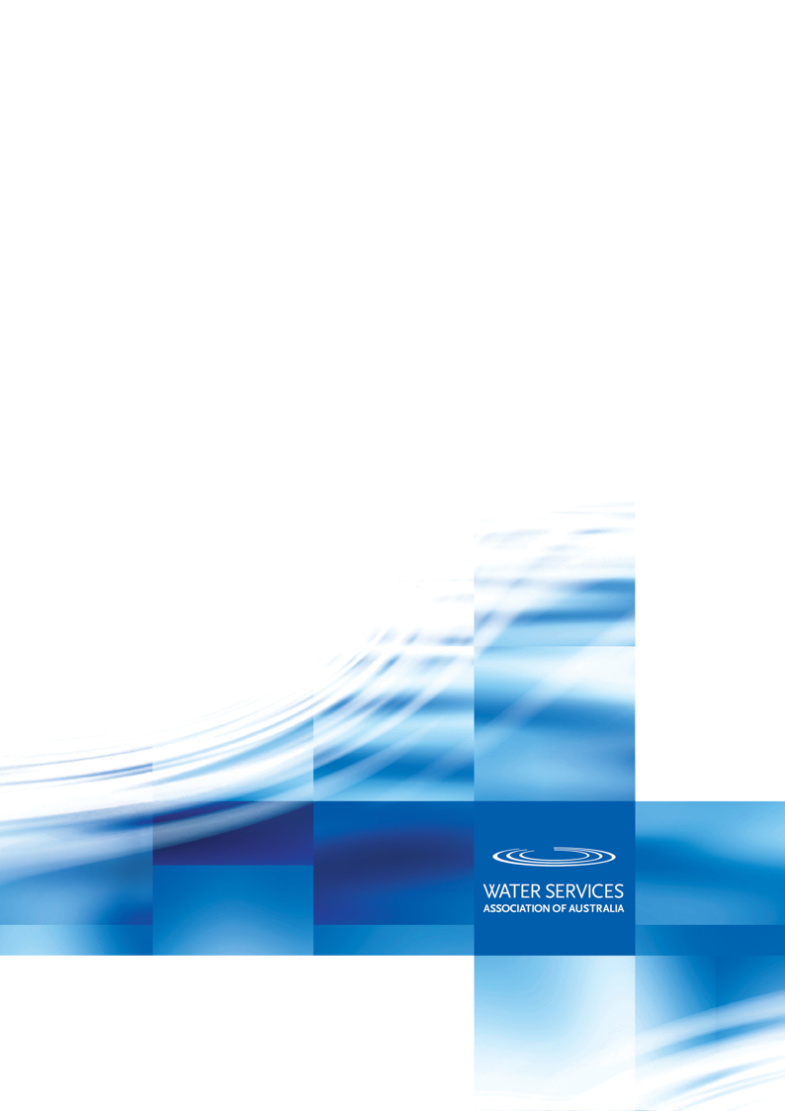
Derwent Industries Pty Ltd
PRODUCT APPRAISAL REPORT 1510 Issue 2

Derwent Spring Hydrant Valves

AS 3952:2002 Water supply – Spring hydrant valve for waterworks purposes

Publication Date: 6 June 2018

Document History
The following information indicates the changes made to this document.
Date | Version
11 September 2015 | Peer Review
1 October 2015 | Published
5 June 2018 | Issue 2 Client Review
6 June 2018 | Issue 2 Publication
Peer Reviewers
Name/Title |  | Organisation |  | Date
Product Appraisal Technical Advisory Group | WSAA |  | 1 October 2015
WSAA Expert Panel | WSAA |  | 1 October 2015
Peter Pittard, WSAA Consultant | WSAA |  | 3 September 2015
Carl Radford, Product Appraisal Manager | WSAA |  | 11 September 2015
Peter Pittard, WSAA Consultant | WSAA |  | 19 April 2018
Carl Radford, Product Appraisal Manager | WSAA |  | 6 June 2018

Overview of WSAA
The Water Services Association of Australia (WSAA) is the peak industry body representing the urban water industry. Our members provide water and sewerage services to over 20 million customers in Australia and New Zealand and many of Australia's largest industrial and commercial enterprises.
Based around our vision of 'customer driven, enriching life', WSAA facilitates collaboration, knowledge sharing, networking and cooperation within the urban water industry. We are proud of the collegiate attitude of our members which has led to industry-wide approaches to national water issues.
WSAA can demonstrate success in the standardisation of industry performance monitoring and benchmarking, as well as many research outcomes of national significance. The WSAA Executive retains strong links with policy makers and legislative bodies and their influencers, to monitor emerging issues of importance to the urban water industry.
WSAA was formed in 1995 as a non-profit organisation to foster the exchange of information between industry, government and the community, and to promote sustainable water resource management.
The urban water industry is committed to anchoring its services to customers' values, and to enrich communities where water services have broad economic, environmental and social values. In line with this our main activities focus on four areas:
- influencing national and state policies on the provision of urban water services and sustainable water resource management
- promoting debate on environmentally sustainable development and management of water resources and the community health requirements of public water supplies
- improving industry performance and establishing benchmarks and industry leading practices for water service processes; and
- fostering the exchange of information on education, training, research, water and wastewater management and treatment and other matters of common interest.
Copyright
This document is copyrighted. Apart from any use as permitted under the Copyright Act 1968, no part of this document may be reproduced or transmitted in any form or by any means, electronically or mechanical, for any purpose, without the express written permission of Water Services Association of Australia Limited.
© Copyright 2018 by WATER SERVICES ASSOCIATION of Australia Limited All rights reserved.

CONTENTS
1 executive summary 5
1.1 Recommendations 5
2 the applicant 5
2.1 The Supplier 5
2.2 The Manufacturer 6
3 the product 6
4 scope of the appraisal 6
5 appraisal criteria 7
5.1 Quality Assurance Requirements 7
5.2 Performance Requirements 7
6 compliance with appraisal criteria 7
6.1 Compliance with Quality Assurance Requirements 7
6.2 Compliance with Performance Requirements 7
6.2.1 Type Testing 7
6.2.2 Suitability for contact with drinking water 8
6.2.3 Components Material List 8
6.2.4 Flanges 8
6.2.5 Polymeric thermal bonded coatings 8
6.2.6 6.2.6 Resilient Seat 9
7 fitting instructions, training and installation 9
8 product marking 9
9 packaging and transportation 9
10 product warranty 9
11 water agency experience with the product or field testing report 9
12 OUTCOMES OF EXPERT PANEL REVIEW 9
13 future works 9
14 disclaimer 10
14.1 Issue of Report 10
14.2 Limits on Reliance on Information and Recommendations 10
14.2.1 Disclaimer of liability 10
14.2.2 Intellectual Property and other rights 10
14.2.3 Need for independent assessment 11
14.3 No Updating 11
14.4 No Warranty 11
APPENDIX A – TECHNICAL MANUAL/BROCHURES 12
APPENDIX B - QUALITY CERTIFICATIONS 17
APPENDIX C - WSA PRODUCT SPECIFICATION 22
APPENDIX D – SUPPLIER CONTACTS 23

- executive summary
Derwent Industries Pty Ltd is a wholly owned operating unit of E. D. Evans Holdings Pty Ltd, a private family owned business originally established in 1963. Other members of the Evans group of companies include Derwent International Pty Ltd, Desal Systems Pty Ltd and Advanced Water Group Pty Ltd.
Alpine Flow Control (Suzhou) Co Limited (AFC) in Suzhou, Jiangsu Province, Peoples Republic of China, manufactures Derwent Spring Hydrant Valves.
This Issue 2 is to include swab version hydrants where the supports that house the helical compression spring and dome can be removed to allow for direct full-bore access to the pipeline for insertion/removal of swabs. Quality assurance documentation has also been updated.
This appraisal covers DN80 Spring Hydrant Valves including the swab version with a DN80 or DN100 flanged outlet to AS 4087 Fig B5. The valves have a pressure classification of PN16.
The Spring Hydrant Valve is intended for use with drinking and recycled water supply and is operated by means of the attachment of a standpipe.
The Derwent Spring Hydrant Valve has ISO Type 5 product certification, StandardsMark No. SMK40418 to AS 3952:2002 Water supply - Spring hydrant valve for waterworks purposes, issued by SAI-Global.
Derwent holds an ISO 9001:2008 Quality Management System licence No QEC2004 issued by SAI-Global and AFC holds an ISO 9001:2008 Quality Management System Licence No. 28794 issued by National Quality Assurance Limited (NQA).
The product range included in this appraisal report meets the requirements of WSA PS – 267 Hydrants (Spring) for Pressure Applications - Water Supply and are therefore considered as ‘fit for purpose’.
  - Recommendations
It is recommended that WSAA members, subject to any specific requirements of the member, accept or authorise the Derwent spring hydrant valves, as detailed in this report for use in water supply pressure pipelines designed and installed in accordance with applicable WSAA Codes, WSAA member integrated Codes and the manufacturer’s requirements, where specified.
- the applicant
The applicant is Derwent Industries Pty Ltd.
  - The Supplier
Derwent Industries Pty Ltd is a wholly owned operating unit of the Evans Group of Companies, a private family owned business originally established in 1963. Other members of the Evans Group include Derwent International Pty Ltd, Desal Systems Pty Ltd and Advanced Water Group Pty Ltd.
The Evans Group has a long history of involvement in manufacturing and marketing products for the Australian water industry. In 1981 Wang Industries Pty Ltd, a member of the Evans Group, began the manufacture of the first Australian made stainless steel repair clamp range, branded as Kawandah. In the 1990’s a range of Varigib repair couplings was introduced to the market. Wang Industries acquired Derwent Foundry, located in Hobart Tasmania, in 1997, which provided manufacturing capability for a complete range of ductile iron fittings.
In 2001 Tyco International acquired Wang Industries, however the Evans Group retained Derwent Foundry, now operating as the manufacturing arm of Derwent Industries Pty Ltd.
Derwent Industries Pty Ltd is the operations and sales arm of the Group whilst Derwent International Pty Ltd is the logistics business, importing pipeline component products for Derwent Industries, to complement their manufactured products.
For more information see: www.derwentindustries.com.au
  - The Manufacturer
Alpine Flow Control (Suzhou) Co Ltd is located in Suzhou, Jiangsu Province, Peoples Republic of China. David Liang, the President of the Company, has over 35 years of experience in the valve manufacturing industry and has previously worked with Karon, AVK, Quick-Tech and Tyco. Many of the AFC staff members are ex Tyco R & D employees.
The company designs and manufactures a wide range of valves for the building services, fire protection, industrial and water market segments. Their valve range includes gate valves, butterfly valves, air release valves, control valves, check valves, pressure reducing valves, Y strainers and other specialist valves. The company employs some 38 personnel, of which more than 40% are technical staff.
AFC exports to a variety of countries around the world selling over 35,000 water valves, predominantly gate valves. The countries include USA, Canada, Mexico, Costa Rica, Chile, Brazil, Russia, India, Indonesia, Philippines, UAE, Vietnam, Malaysia, Italy, Spain, United Kingdom and Australia. Existing approvals for gate valves include WRAS, FM and UL.
The Spring Hydrant Valves are assembled and tested at the AFC manufacturing facility in Suzhou. Components are sourced locally in accordance with AFC specifications. Polymeric coatings are applied in-house utilising an electrostatic spray technique.
- the product
Derwent DN 80 spring hydrant valves and swab hydrants are manufactured by Alpine Flow Control (Suzhou) Co Limited (AFC) in Suzhou, Jiangsu Province, Peoples Republic of China to comply with the requirements of AS 3952:2002 Water supply - Spring hydrant valve for waterworks purposes.
Derwent supplies standard spring hydrants and swab version spring hydrants, where the supports that house the helical compression spring and dome can be removed to allow for direct full-bore access to the pipeline for insertion/removal of swabs.
The Derwent spring hydrant valves are flanged to AS 4087 Fig B5, DN 80 or DN 100.
All internal and external surfaces of the Derwent spring hydrant valve body and yoke are coated with Resicoat R4-ES, a Fusion Bonded Epoxy, supplied by Akzo Nobel Pty. Ltd. and applied by AFC using an electrostatic spray technique.
The spring hydrant valves are rated as PN16 with an Allowable Operating Pressure (AOP) of 1600 kPa.
For recycled water identification options, Derwent can provide spring hydrant valves with a purple-coated yoke.
Ancillary products such as flange gaskets, fasteners and jointing lubricant are also available.
Literature for the Derwent DN 80 spring hydrant valves is provided in Appendix A.
- scope of the appraisal
The scope of this appraisal covers DN80 Derwent spring hydrant valves with DN80 and DN100 flanged outlets, as described in Section 3 and listed in the Schedule to the StandardsMark in Appendix B.
- appraisal criteria
  - Quality Assurance Requirements
The WSAA product appraisal network accepts spring hydrant valves manufactured in compliance with AS 3952:2002 Water supply-spring hydrant valve for waterworks purposes and duly certified by means of an ISO Type 5 product certification scheme undertaken by a JAS-ANZ accredited Conformity Assessment Body (CAB) or by an international accreditation system recognised by JAS-ANZ.
The manufacturer is generally expected to have a production management and control system that has been duly accredited in accordance with AS/NZS ISO 9001 as a prerequisite to undergoing a product certification audit.
  - Performance Requirements
Derwent spring hydrant valves have been appraised for compliance with AS 3952:2002 Water supply-spring hydrant valve for waterworks purposes.
Appraisal criteria are also determined by the WSAA Product Appraisal Technical Advisory Group and regularly reviewed to ensure that the criteria reflect the requirements of WSAA members.
The following Product Specifications are relevant to this application:
WSA PS- 267 Hydrants (Spring) for Pressure Applications - Water Supply
WSA PS 312 Flange Gaskets and O-rings
Copies of the above Product Specification can be found in Appendix C or downloaded from the WSAA website.
- compliance with appraisal criteria
  - Compliance with Quality Assurance Requirements
          - Derwent Industries Pty Ltd, has a Quality Management System certified by SAI Global in compliance to ISO 9001:2008 with Certificate No. QEC2004.
          - Alpine Flow Control (Suzhou) Co Ltd, has a Quality Management System certified by National Quality Assurance Limited (NQA) in compliance with ISO 9001:2008 with Certificate No. 28794.
          - The Derwent Spring Hydrant Valves have ISO Type 5 product certification, StandardsMark No. SMK40418 to AS 3952:2002 Water supply-Spring hydrant valve for waterworks purposes, issued by SAI-Global.
          - Akzo Nobel Resicoat R4 has ISO Type 5 product certification, StandardsMark No.SMKP 25583 to AS/NZS4158:2003 Thermal-bonded polymeric coatings on valves and fittings for water industry purposes
Derwent has also submitted copies of other relevant Quality Assurance licences for the various suppliers of the components used in assembly of the spring hydrant valves. These have not been included in this report due to ‘commercial in confidence’ reasons.
  - Compliance with Performance Requirements
    - Type Testing
Derwent has provided copies of reports detailing results of Type Tests conducted at the Queensland Testing Laboratory Pty Ltd, a NATA accredited laboratory for both the standard hydrant and swab versions of the hydrants. The reports demonstrate compliance with the type test requirements of AS3952:2002. A copy of the test reports is available upon request from the WSAA Product Appraisal Manager.
    - Suitability for contact with drinking water
Derwent has submitted a Test Report from the National Building Material Industry Hardware and Plumbing Equipment Quality Supervision and Test Centre in Beijing to demonstrate compliance of the DN80 Spring Hydrant Valve with AS/NZS 4020:2005 Testing of products for use in contact with drinking water. The laboratory is accredited by CNAS and recognised by ILAC-MRA.
    - Components Material List
AS 3592 Table 2.1 requires spring hydrant valves manufactured from ductile iron to conform to minimum Grade 400-12. Higher strength ductile irons in accordance with AS 1831 are acceptable. The Derwent spring hydrant valves are manufactured using the higher grade 500-7 material designation.
The material requirements of the components used for the Derwent spring hydrant valves comply with AS 3592. Material test certificates have been submitted for each component to demonstrate conformance to the nominated materials.
Table 2 DERWENT hydrant valves Components Material List
Component | Material | Standard | Minimum Grade | Derwent | Comment
Body and Yoke | Ductile iron | AS 1831 | 400-12 | 500-7 | Complies
Dome | Copper Alloy | AS 1565 | C48600 | C48600 | Complies
Helical Compression Spring | Stainless Steel | ASTM A276 | 304 or 316 | 316 | Complies
Removable Support (Swab) | Ductile iron | AS 1831 | 400-12 | 500-7 | Complies
Resilient Seat | Synthetic Rubber | AS 1646 | EPDM 67-73 IRHD | EPDM 67-73 IRHD | Complies
Fasteners | Stainless Steel | ASTM A276 | 316 | 316 | Complies

    - Flanges
Flange dimensions comply with AS 4087:2011 Metallic flanges for waterworks purposes – Figure B5 (Class 16), DN 80 or DN 100.
Recommended installation is in accordance with the requirements of AS 4087.
WSAA recommends that PN16 flange gaskets are made from solid 3mm thick EPDM and comply with WSA 109:2011 Industry Standards for Flange Gaskets and O Rings.
    - Polymeric thermal bonded coatings
Clause 4 of AS 3953:2002 requires all internal and external surfaces of the body and yoke to be coated with a polymeric coating in accordance with AS/NZS 4158 Thermal-bonded polymeric coatings on valves and fittings for water industry purposes.
The Derwent spring hydrant valve body and yoke are coated with Akzo Nobel Resicoat R4-ES, a thermosetting fusion bonded epoxy. The coating is applied in-house by AFC using an electrostatic spray technique.
Akzo Nobel Resicoat R4 is covered by a StandardsMark product certification licence to AS/NZS 4158:2003.
Coatings are tested for thickness, continuity and adhesion during manufacture to ensure coating integrity. Derwent has supplied copies of the coating application procedures and typical test reports to demonstrate compliance to AS/NZS 4158. Application procedures are also audited by SAI-Global in conjunction with their regular StandardsMark certification audits.
For use with recycled water, Derwent can coat the yoke with a purple coloured fusion bonded epoxy coating.
    - 6.2.6 Resilient Seat
WSA PS 267 requires that the spring hydrant resilient seat has a minimum thickness of 5mm. Derwent has provided a drawing of the seal to confirm that the thickness of the seal is 6.5mm.
- fitting instructions, training and installation
Spring hydrant valves are standard water industry products and all general specification information is shown in the data sheets in Appendix A.
- product marking
The Derwent spring hydrant valves have the following markings conforming to AS 3952-2002:
Manufacturer’s name or mark – DERWENT
Nominal flange size – DN XX
Year of manufacture – XXXX
Class of valve – PN16
Australian Standard – AS 3952
StandardsMark Logo – √√√√√
The marking layout is presented on drawing number SE-AFC-SFHX-80-100-16-V1 in Appendix A.
- packaging and transportation
The spring hydrant valves are packed onto pallets using corrugated cardboard or similar material to avoid contact and to act as a separation to prevent damage during transport. The pallets are then shrink-wrapped.
- product warranty
The products are covered by the normal commercial and legal requirements of the Competition and Consumer Act 2010 (Cth), which covers manufacture to the relevant standard, and details of Derwent’s warranty is included in their terms and conditions of sale.
- water agency experience with the product or field testing report
Derwent spring hydrant valves are considered standard products and installation trials were not required as part of this report.
The approval process of the Derwent spring hydrant valve range by individual Water Agencies will enable any issues associated with quality and performance to be reported and addressed.
- OUTCOMES OF EXPERT PANEL REVIEW
There are no outstanding requests.
- future works
There are no outstanding future works items.
- disclaimer
This Product Appraisal Report (Report) is issued by the Water Services Association of Australia Limited on the understanding that:
This Report applies to the product(s) as submitted. Any changes to the product(s) either minor or major shall void this Report.
To maintain the recommendations of this Report any such changes shall be detailed and notified to the Product Appraisal Manager for consideration and review of the Report and appropriate action. Appraisals and their recommendations will be the subject of continuous review dependent upon the satisfactory performance of products.
WSAA reserves the right to undertake random audits of product manufacture and installation. Where products fail to maintain appraised performance requirements the appraisal and its recommendations may be modified and reissued. Appraisal reports will be reviewed and reissued at regular intervals not exceeding five (5) years.
The following information explains a number of very important limits on your ability to rely on the information in this Report. Please read it carefully and take it into account when considering the contents of this Report.
Any enquiries regarding this report should be directed to the Program Manager, Carl Radford, Phone: 03 8605 7601 email carl.radford@wsaa.asn.au.
  - Issue of Report
This Report has been published and/or prepared by the Water Services Association of Australia Limited and nominated Project Manager and peer group of technical specialists (the Publishers).
The Report has been prepared for use within Australia only by technical specialists that have expertise in the function of products such as those appraised in the Report (the Recipients).
By accepting this Report, the Recipient acknowledges and represents to the Publisher(s) and each person involved in the preparation of the Report that the Recipient has understood and accepted the terms of this Disclaimer.
  - Limits on Reliance on Information and Recommendations
    - Disclaimer of liability
Neither the Publisher(s) nor any person involved in the preparation of the Report accept(s) any liability for any loss or damage suffered by any person however caused (including negligence or the omission by any person to do anything) relating in any way to the Report or the product appraisal criteria underlying it. This includes (without limitation) any liability for any recommendation or information in the Report or any errors or omissions.
    - Intellectual Property and other rights
The Water Services Association of Australia Limited does not undertake any assessment of whether the importation, manufacture, sale or use of the Product the subject of this Report infringes the intellectual property rights or proprietary rights of any person. Recipients of the report should undertake their own assessment of whether (as relevant) the importation, manufacture, sale or use of the relevant Products infringe the intellectual property rights or other proprietary rights of any person. If the Product infringes intellectual property rights or other proprietary rights there is potential for the supply of the Products to be interrupted.
From time to time the Water Services Association of Australia Limited and the other Publishers may receive notice of allegations that the importation, manufacture, sale or use of the Product infringes intellectual property rights or other proprietary rights. The Water Services Association of Australia Limited's policy is to not refer to such allegations in its reports or take any other steps to put Recipients on notice of such allegations, unless and until it is aware that the allegations have been admitted or proved in Court. As such, Recipients acknowledge, agree and accept that the Water Services Association of Australia Limited may have information in its possession about intellectual property rights infringement allegations or other infringement allegations in relation to the Product which are not referred to or disclosed in this Report and which are not otherwise communicated to Recipients.
    - Need for independent assessment
The information and any recommendation contained (expressly or by implication) in this Report are provided in good faith (and subject to the limitations noted in this Report). However, you should treat the information as indicative only. You should not rely on that information or any such recommendation except to the extent that you reach an agreement to the contrary with the Publisher(s).
This Report does not contain all information that a person might require for the purposes of assessing any product discussed or appraised within it (Product). The product appraisal criteria used in preparing this Report may not address all relevant aspects of the Product.
Recipients should seek independent evidence of any matter which is material to their decisions in connection with an assessment of the Product and consult their own advisers for any technical information required. Any decision to use the Product should take into account the reliability of that independent evidence obtained by the Recipient regarding the Product.
Recipients should also independently verify and assess the appropriateness of any recommendation in the Report, especially given that any recommendation will not take into account a Recipient’s particular needs or circumstances.
WSAA has not evaluated the extent of the product liability and professional indemnify insurance that the provider of the product maintains. Recipients should ensure that they evaluate the allocation of liability for product defects and any professional advice obtained in relation to the product or its specification including the requirements for product liability and professional indemnity insurance.
  - No Updating
Neither the Publisher(s) nor any person involved in the preparation of this Report [has] [have] any obligation to notify you of any change in the information contained in this Report or of any new information concerning the Publisher(s) or the Product or any other matter.
  - No Warranty
The Publisher(s) do[es] not, in any way, warrant that steps have been taken to verify or audit the accuracy or completeness of the information in this Report, or the accuracy, completeness or reasonableness of any recommendation in this Report.

APPENDIX A – TECHNICAL MANUAL/BROCHURES
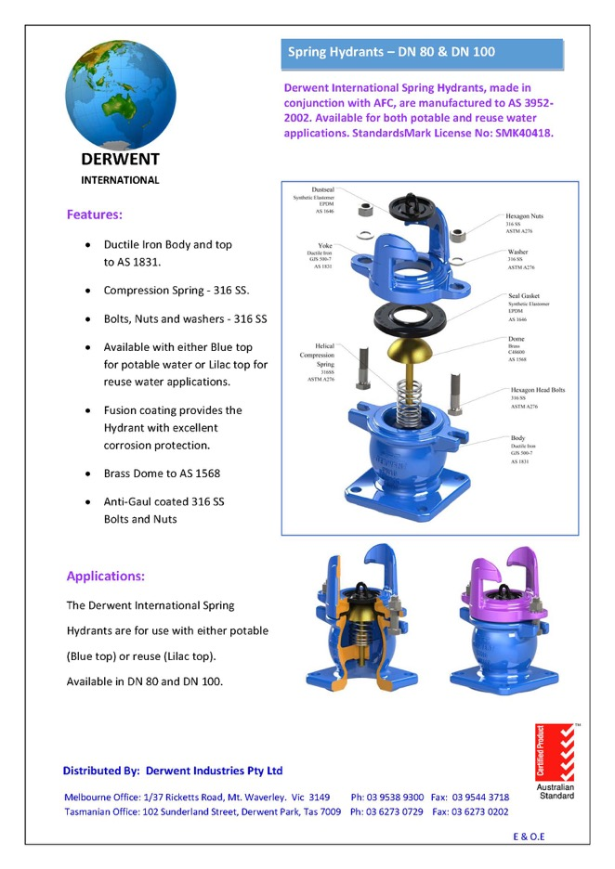
EXPLODED VIEW OF DERWENT SPRING HYDRANT
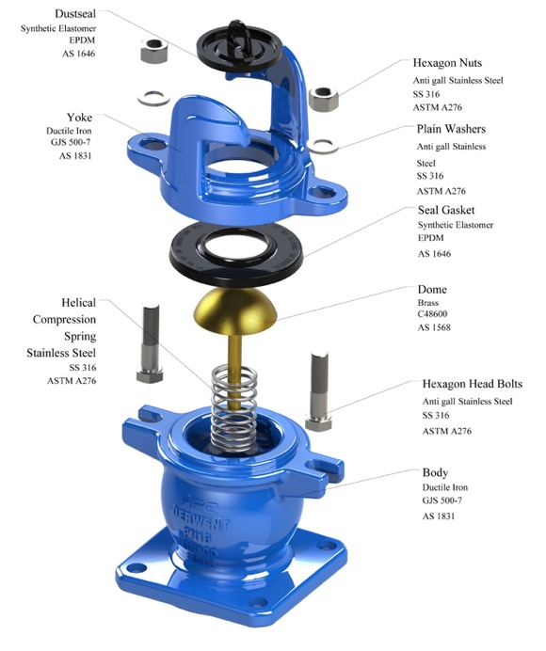

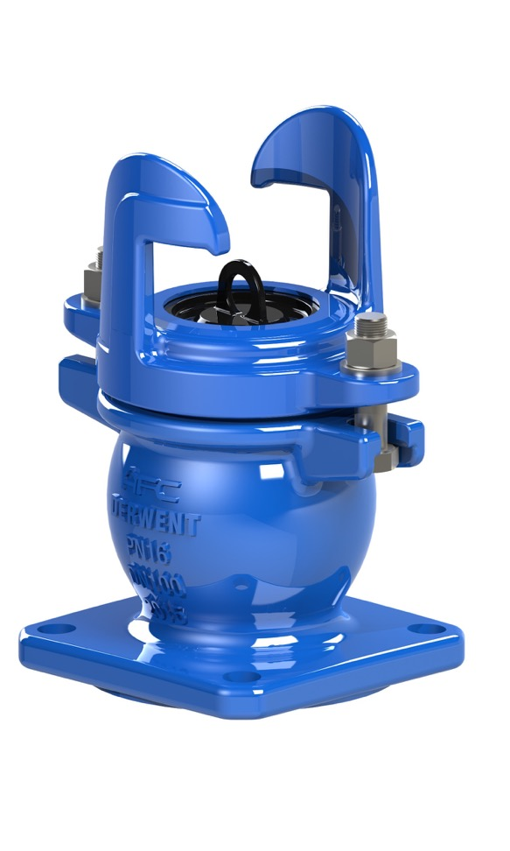
DERWENT SPRING HYDRANT

CUTAWAY DERWENT SPRING HYDRANT
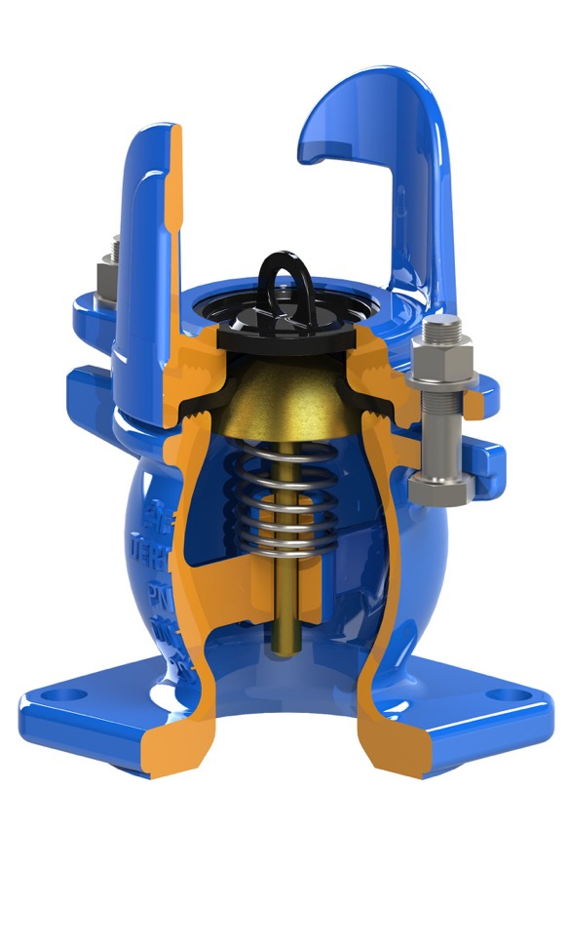

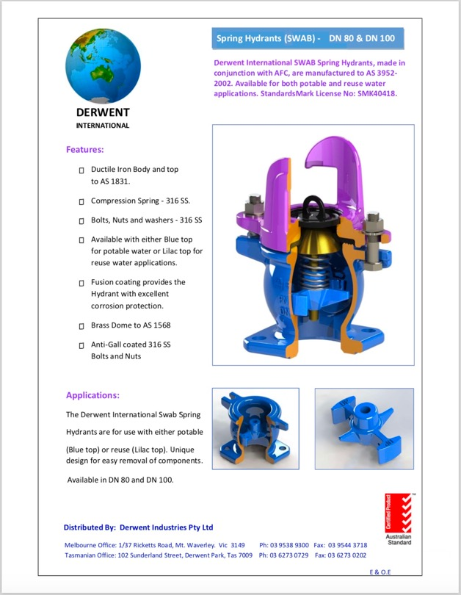
APPENDIX B - QUALITY CERTIFICATIONS
Copies of the following Quality Certification Certificates are available for downloading from the WSAA members only website.
TABLE B1
DERWENT INDUSTRIES PTY LTD– MANAGEMENT SYSTEMS
Business Address: Derwent Park, TAS
Quality Systems Standard | ISO 9001:2008
Certification licence no. | QEC 2004
Certifying agency | SAI-Global
First date of certification | 8 August 1994
Current date of certification* | 9 July 2017
Expiry date of certification** | 14 September 2018
TABLE B2
ALPINE FLOW CONTROL (SUZHOU) CO LTD–MANAGEMENT SYSTEMS
Business Address: B5 Chaoyang Factor, Caohu Industrial Park, Xiangcheng Economic Development Zone, Suzhou City, Jiansu Province, PRC
Quality Systems Standard | ISO 9001:2008
Certification licence no. | 28794
Certifying agency | NQA
First date of certification | 19 November 1999
Current date of certification* | 31 May 2016
Expiry date of certification** | 14 September 2018
TABLE B3
DERWENT INTERNATIONAL – PRODUCT CERTIFICATION
Business Address Mt Waverley, VIC
Product Standard | AS 3952:2002
Certification licence no | SMKP 22026
Certifying agency | SAI Global
First date of certification | 8 May 2015
Current date of certification | 18 May 2018
Expiry date of certification: | 7 May 2020

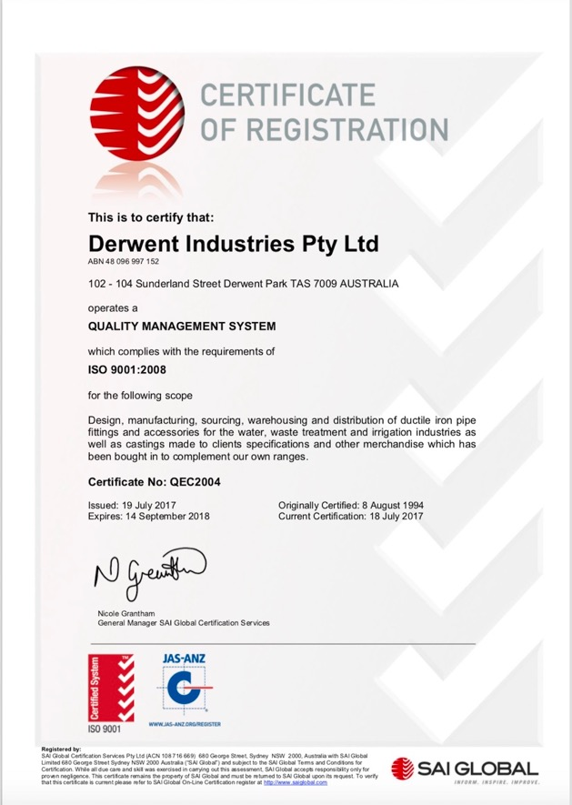
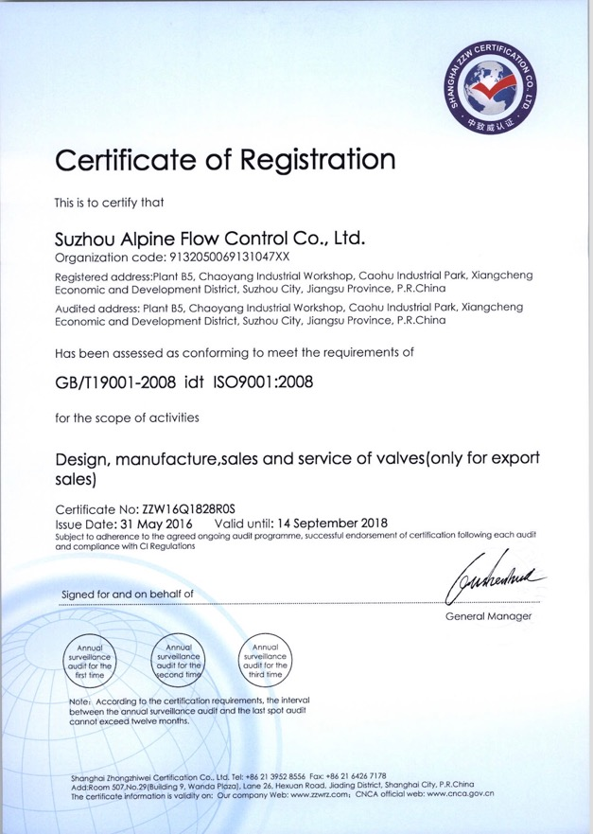
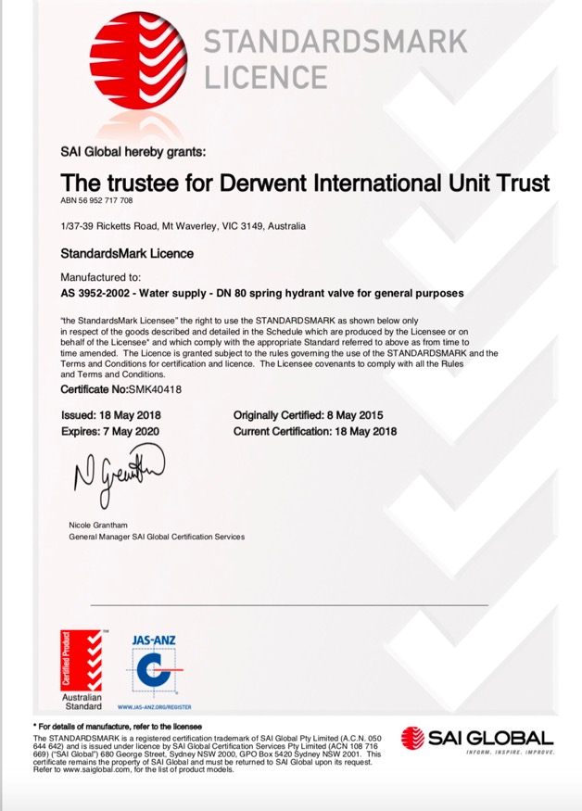
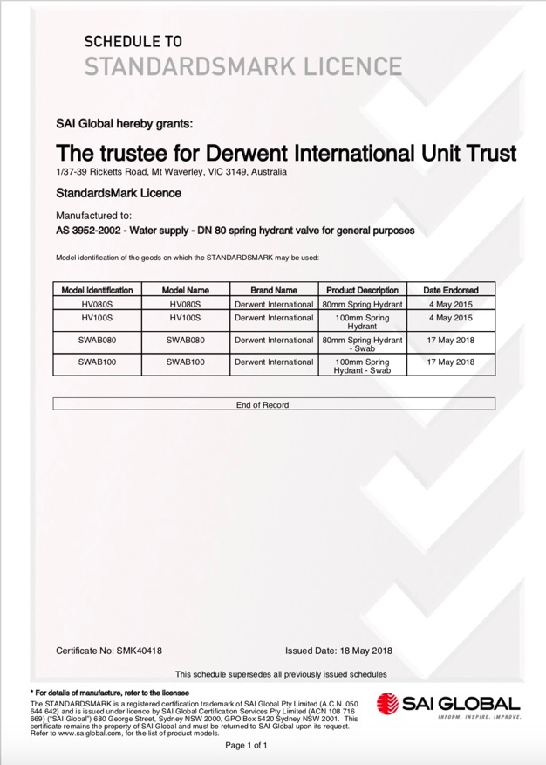

APPENDIX C - WSA PRODUCT SPECIFICATION
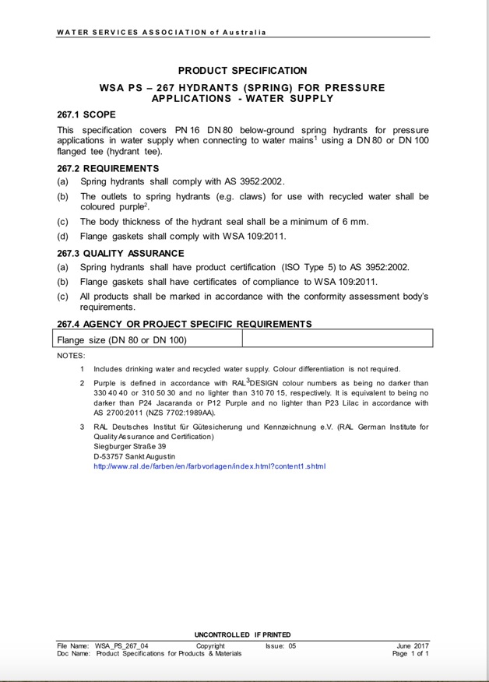
APPENDIX D – SUPPLIER CONTACTS

Derwent Industries Pty Ltd
17 Metcalf Drive
Dandenong South Vic 3175
Contact: Stuart Evans
Phone: 03 9793 9054
Mobile: 0409 532 154
Email: sales@derwentindustries.com.au
Web: www.derwentindustries.com.au

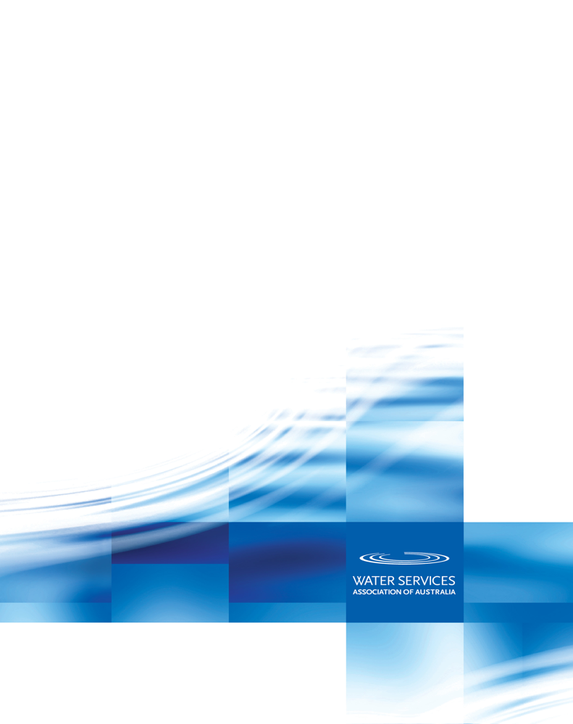
Melbourne Office
Level 8, 401 Docklands Drive
Docklands VIC 3008
Phone: (03) 8605 7666

Sydney Office
Level 9, 420 George Street
Sydney NSW 2000
GPO Box 915
Sydney NSW 2001
Phone: (02) 9221 5966
www.wsaa.asn.au

